FOUNDER’S DAY 8 DECEMBER 2021

ANNUAL DINNER AT THE CHARTERHOUSE, LONDON

6 .00 pm Choral Evensong with commemoration of Benefactors
Service conducted by Canon Ann Clarke, Preacher, The Charterhouse
The Reverend Clive Case, Chaplain of Charterhouse
Guest Preacher
Music by the School’s Chamber Choir under the direction of Mr Mark Shepherd, Director of Music
6.45 pm Reception in the Great Chamber
7.30 pm Dinner in the Great Hall
Guest Speaker
10.15 pm Dinner ends
Carriages depart

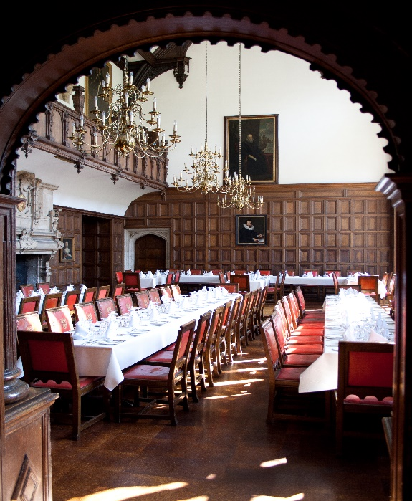
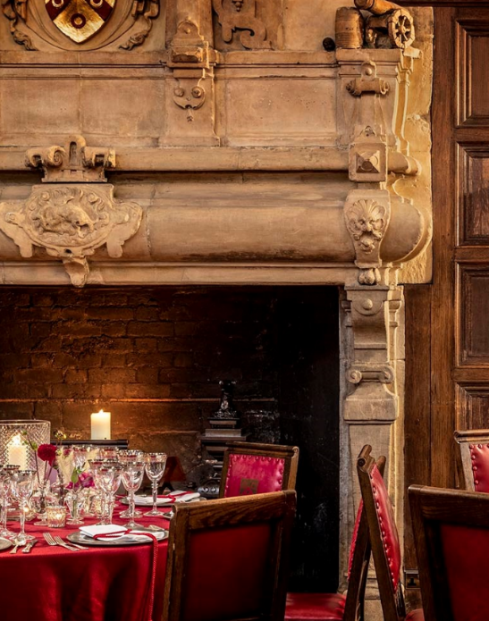

FOUNDER’ S DAY STEWARDS 2021
The Headmaster, Dr Alex Peterken The Master, Ann Kenrick
Julian Bridger (H71, Brother) Tom Foulger (g04) William Lynch (H83)
Ian McBryde (H73) Jim Miller (P85) Arun Silva (G16)
Charles Joseph (H73)
Floreat Aeternum Carthusiana Domus
In association with

